“Windows Vista is helping us add value to our overall business. By being ahead of the technology curve … we’ve got the stability and resources to streamline our business processes.”
Customer: Pelican Media
Web Site: www.pelicanmedia.ca
Customer Size: 1-99
Country or Region: Canada
Industry: Media & Entertainment
Partner: Crossman Graphic Supply
Web Site: www.crossmansupply.com

Customer Profile
Saskatoon, Saskatchewan–based Pelican Media is a printing company that handles signs, banners, and digital graphics for conventions and special events.

Software and Services
- Windows Vista™
- Microsoft® Office system
- Microsoft Office Professional 2007

Hardware
- Dell XPS Gen workstations
- Dell OptiPlex 745 workstations
- Lenovo 3000 Family portable computers
- Lenovo 3000 Family workstations
- Toshiba Tecra M7 Tablet PC
For more information about other Microsoft customer successes, please visit: www.microsoft.com/casestudies
Ken Anklovitch, Co-owner and Lead Production Manager, Pelican Media
After moving to a standardized environment in 2006, printing company Pelican Media experienced a significant jump in productivity and recognized the benefits of newer technology. Thus, the company recently upgraded its client computers to the Windows Vista™ operating system with the help of partner Crossman Graphic Supply. With the upgrade, Pelican Media is experiencing another increase in user productivity, as well as enhanced system manageability.

Business Needs
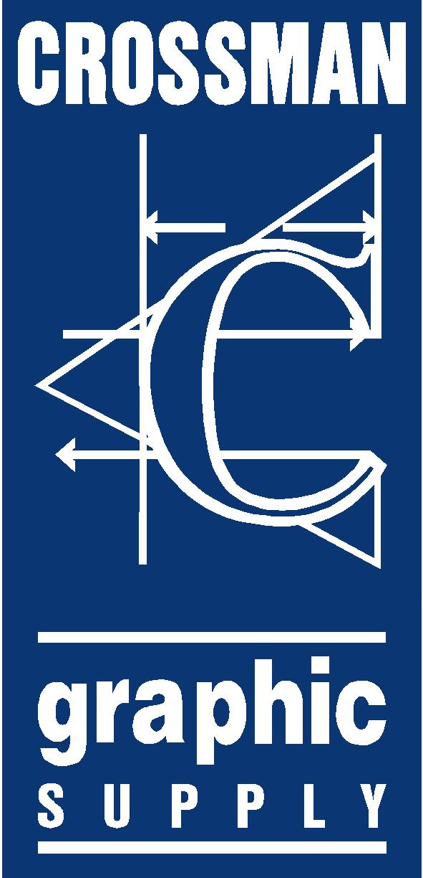 |  |  | 

Pelican Media, a large-format printing company, handles the critical signage needs of companies across Saskatchewan, Canada. With 30 employees, the company maintains a fast-paced environment to respond to everything from enormous printing jobs to last-minute requests.

Over the years, the technology needs of Pelican Media grew along with the company. The up-tempo nature of the business, however, produced a heterogeneous IT environment because Pelican Media implemented systems to meet specific issues as they arose. The result was an infrastructure that included a Red Hat Linux server and a mixture of operating systems—from Red Hat Linux to Windows® 95—on the company’s 16 workstations and portable computers.

When its Linux server failed in 2006, Pelican Media nearly lost all its data, which provided the impetus for creating a more stable, maintainable environment. The company sought help from long-time partner Crossman Graphic Supply, a Microsoft® Gold Certified Partner that serves the printing industry. Crossman helped standardize the Pelican Media environment, moving the company to a server running the Windows Server® 2003 operating system and upgrading the client computers to the Windows XP operating system. “We wanted to help Pelican Media establish a more solid, secure network from which the company could more easily adopt new technology,” explains Derek Sanderson, Chief Information Officer for Crossman Graphic Supply.

The improvements to its IT environment changed the way that Pelican Media thought about technology, encouraging the company to take advantage of security and productivity advances as they became available. “Since our recent move to the Windows platform from a hybrid environment, our business productivity has easily doubled,” says Ken Anklovitch, Co-owner and Lead Production Manager for Pelican Media. “That positive experience, combined with our partner’s background with us, gave us the confidence to try other new systems to further bolster our efficiency.”

Solution
When the opportunity arose to adopt the next Microsoft operating system, Pelican Media took it. The company worked with Crossman to deploy the Windows Vista™ operating system on all of its computers. “We wanted to upgrade to Windows Vista right away to take advantage of the positive changes in the technology,” says Anklovitch.

One of the challenges with upgrading, however, was potential incompatibility with the company’s four large-format printers, which ran on significantly older technology. To allay concerns, Crossman used the Microsoft Application Compatibility Toolkit and worked with third-party print vendors to address potential issues with drivers and software. “The professional and thorough level of support and attention to detail that we received from Crossman was above and beyond our expectations,” says Anklovitch. “In fact, our partner made a special effort to transfer knowledge to us so that we could effectively maintain our computers ourselves.”

The move to Windows Vista began in August 2006, when Crossman upgraded a few computers to Windows Vista to run alongside the Pelican Media production environment. Between then and January 2007, the company upgraded the rest of its 16 client computers to Windows Vista. “The migration was totally straightforward—I didn’t even use deployment tools, and I still completed the upgrade 50 percent more quickly than previous implementations,” says Sanderson. “Essentially, the drivers install automatically. I was able to just enter one piece of information and then walk away, leaving the computer to upgrade on its own.”

To ensure that users were able to immediately be productive on the new system, Crossman conducted a thorough one-day training session with users and also developed a custom “how-to” guide for Windows Vista in the Pelican Media environment.

Benefits
With its operating system upgrade, Pelican Media is experiencing a lower total cost of ownership due to increased productivity and reliability. Plus, its users are finding that it’s easier to accomplish their work. “Windows Vista is helping us add value to our overall business. By being ahead of the technology curve—as opposed to behind it—we’ve got the stability and resources to streamline our business processes,” says Anklovitch.
- Improved user productivity. For Pelican Media, a company that makes graphics its business, the visual enhancements in Windows Vista are making it faster for users to manage their applications and move through their work. “We’re seeing a 20 percent boost to our productivity because of our Windows Vista upgrade,” says Anklovitch. “For one thing, switching between several design programs with Windows Flip 3D allows our designers to quickly find the design that they need because it shows them a large, clear preview. And with no more need to open and deal with huge graphics programs, it’s faster and easier to present previews of artwork to customers.”

- The gadget functionality in the Windows Sidebar helps speed the company’s processes because users keep to-do lists and notes right on the desktop. Pelican Media also makes weather-related information available through a quick-reference gadget so that users know if the conditions are right for applying external signage.

- Increased reliability for U.S.$2,500 in increased monthly revenue. The new operating system is helping Pelican Media avoid the significant downtime that its employees used to experience due to the large graphics programs with which they work. “Windows Vista saves us significant downtime because the system manages application errors so much better. We can close an application without shutting down the entire system, so we can finish jobs more quickly,” says Anklovitch. “As a result, we’re gaining one full production day each month, which equates to about $2,500.”

